How to use this template

- Click here to see an example of an article in the standard Bio-protocol format.
- Prepare your manuscript using Microsoft Word by filling in the template below, using the format styles presented for each section. Our manuscript template does not accept any color or shading in the text.
- Delete this section and start with the “Title” on the next page, replacing the text of each section with your content. Delete all notes with instructions.
- Do not change the format of any level 1 section headings. Please note that the following sections are required:
Key features
Keywords
Abstract
Background
Materials and reagents (for wet-lab protocols)
Software and datasets
Procedure
Validation of protocol
Acknowledgments
Competing interests
References
- Format all in-text citations as reference numbers (e.g., “The protocol described here was based on previous works [1]”). All manuscripts must use the Bio-protocol referencing style, which can be found via EndNote or CSL reference manager tools such as Zotero. You can also use the direct link from GitHub. When citing multiple sources, the numbers should be separated by a comma or a dash, for example, [1,3,5] or [1–3]. Note that references must be cited in sequential order throughout the text.

Note: If you encounter problems related to the preparation of your manuscript based on this template, or if you have specific questions or suggestions on how to improve the template, we welcome your feedback; please email us at anca.savulescu@ed.bio-protocol.org.

Protocol Title -- for bioinformatics or computational biology protocol

Author 1^{1, #, §}, Author 2^{1, 2, $, #}, Author 3², and Author 4^{2,} *

¹Dept/Center, Institution name, City, Country
²Dept/Center, Institution name, City, Country
$Current/Present address: Dept/Center, Institution name, City, Country
*For correspondence: email address
#[not required] Contributed equally to this work
§[not required] Technical contact: email address

Abstract

Introduce the research field (1–2 sentences), provide context by mentioning other existing and previously used techniques (1–2 sentences), summarize the protocol (3–4 sentences), and finish by summarizing the advantages of the protocol presented (1–2 sentences). Do not include references (e.g., to articles or figures) in the Abstract.

Key features

- Add up to four Key Features, each with a maximum of 25 words (click here for an example).
- Key Features should convey the most important elements of your protocol and not simply repeat or condense ideas expressed in the Abstract.
- They should highlight characteristics that will allow readers to determine whether the protocol is relevant to their work.
- For example, they might mention experimental contexts in which the protocol was developed and is most useful.

Keywords: Keyword 1, Keyword 2, Keyword 3, … (5–8 in total)

This protocol is used in: Journal Name (Year), DOI: xxxxx
Cite the original article(s) where this protocol was used/validated (only relevant if you have articles listed in the validation section).

Graphical overview

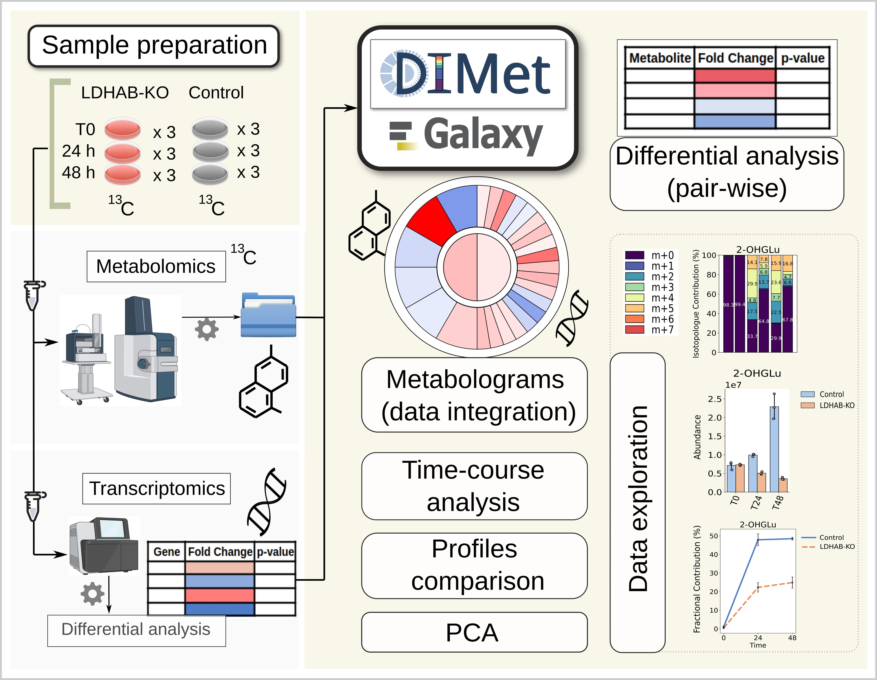

Example graphical overview. Include a figure title for clarity. The graphical overview is highly recommended but not required. Provide a graphical overview of the procedure in a figure format, either as a flowchart of the method/procedures or highlighting key steps. Minimize the use of text in the graphical overview and ensure all text, numbers, or symbols are readable. Be sure to distribute the content evenly in the figure and avoid large blank spaces. The graphical overview should not be identical to any other figure in the article and should not be a simple combination of a large paragraph of text and an image. All figures should be high resolution (300–900 dpi) and created in one of the following formats: PNG, JPEG, SVG, PSD, or TIFF. See more information below and on the author guidelines page here. Example from Galvis et al. (2024).

Background

Briefly introduce the research area that your protocol can be used to advance. Discuss previously described related methodologies and summarize the advantages and limitations of using your protocol over other published methods. If applicable, elaborate on other possible applications of the protocol.

Materials and reagents (optional; include this section if there is a wet-lab component of your protocol)

Note: Make sure you include all and only the items used in the protocol and organize them according to the categories below. Information on vendor/manufacturer and catalog number is mandatory. Provide storage information (i.e., temperature and shelf-life) for critical reagents or as appropriate. Provide references or instructions to acquire or generate custom-made materials, reagents, or equipment (see the section below). Use consistent nomenclature throughout the manuscript.

Biological materials

1. Bacterial strain name 1 (Manufacturer, catalog number/origin: XXX)
2. Virus strains name 1 (Manufacturer, catalog number/origin: XXX)
3. Cell line name 1 (Manufacturer, catalog number/origin: XXX)
4. Biological samples 1 (Manufacturer, catalog number/origin: XXX)
5. …

Reagents

1. Product 1 name (Manufacturer, catalog or CAS number: XXXX)
2. …

Solutions

1. Solution name 1 (abbreviation, if applicable) (see Recipes)
2. …

Recipes

Note: Be precise about the ingredients (e.g., buffer or media), quantities, and conditions established for your experiments. Note that the omission of minor details from recipes (e.g., type of water used or storage conditions) might lead to the failure of the experiment.
1. Recipe name 1
Reagent | Final concentration | Quantity or Volume
Reagent name 1 | xx mM | xx mL
Reagent name 2 | xx g/L | xx g
… | … | …
Total (optional) | n/a | xx mL

2. Recipe name 2
Reagent | Final concentration | Quantity or Volume
Reagent name 1 | xx mM | xx mL
Reagent name 2 | xx g/L | xx g
… | … | …
Total (optional) | n/a | xx mL

Laboratory supplies

1. Consumable name 1 (Manufacturer, catalog number: XXXX)
2. Consumable name 2 (Manufacturer, catalog number: XXXX)
3. …

Equipment (Optional)

1. Equipment 1 name (Manufacturer, catalog number/model: XXXX)
2. Equipment 2 name (Manufacturer, catalog number/model: XXXX)
3. …

Software and datasets

Note: List individual software or datasets required to complete the protocol, including version and release date. Provide references for items that are not commercially available. Note whether the software is free to use or requires a license (and detail the license needed) and, if possible, provide free alternatives to commercial software.

Type | Software/dataset/resource | Version | Date | License | Access (free or paid)
Data
Software 1
Software 2
…
Workflow manager

Procedure

General notes:
1. The Procedure section should provide a step-by-step guide for the use of the software or pipelines.
2. If a GitHub/Bitbucket repository is provided, please create a persistent identifier (digital object identifier, DOI) for your repository and include it in your protocol.
3. Please ensure that README files and reinstantiable codes are included.
4. If the procedure includes any wet-lab protocol steps, see instructions in Section C, below.

A. Section title 1
1. Write chronological, step-by-step instructions for the protocol. We recommend dividing the major steps of the protocol into separate sections (A, B, C, …) with descriptive subtitles.
2. Write steps as instructions using the active voice and present tense (e.g., write "Parse the output files from the homology searches” instead of “The output files from the homology searches were parsed").
i. You may use specific labels and notes immediately below the relevant step (see an example here):
ii. Note: Use when marking any other comments, suggestions, or recommendations relevant to a specific step.
Note: Notes that apply to the protocol more broadly and are not only relevant to a specific step or section should be added to the General notes and troubleshooting (see below).
iii. See Troubleshooting: May be used to mark steps where troubleshooting information is available in the General Notes and Troubleshooting section (see below). This may be information on what to do if part or all of the protocol does not work, referencing specific steps, or noting what can be changed or optimized if particular outcomes happen.
2. Provide representative data (intermediary and final) and notes/tips to help others. Your description should provide enough information for a user to perform the analysis without additional help.
3. Code and scripts: Relevant software or data analysis pipelines can be made available via external platforms as described in the Software table (above). Code or scripts could also be presented in the main text of the protocol, or submitted as supplementary file(s).
4. Provide images (e.g., Figure 1), tables (e.g., Table 1), videos (e.g., Video 1), and algorithms (e.g., Algorithm 1) for key steps, representative data (intermediate and final) to illustrate the type of results obtained, and notes/tips. Embed all figures and tables within the text, placing each one close to its first mention. Ensure figures, tables, videos, and algorithms are numbered in the order they are referenced.
5. If special training is required to perform some steps or operate specific equipment, please note this in the protocol and consider mentioning it in the Key Features section as well.

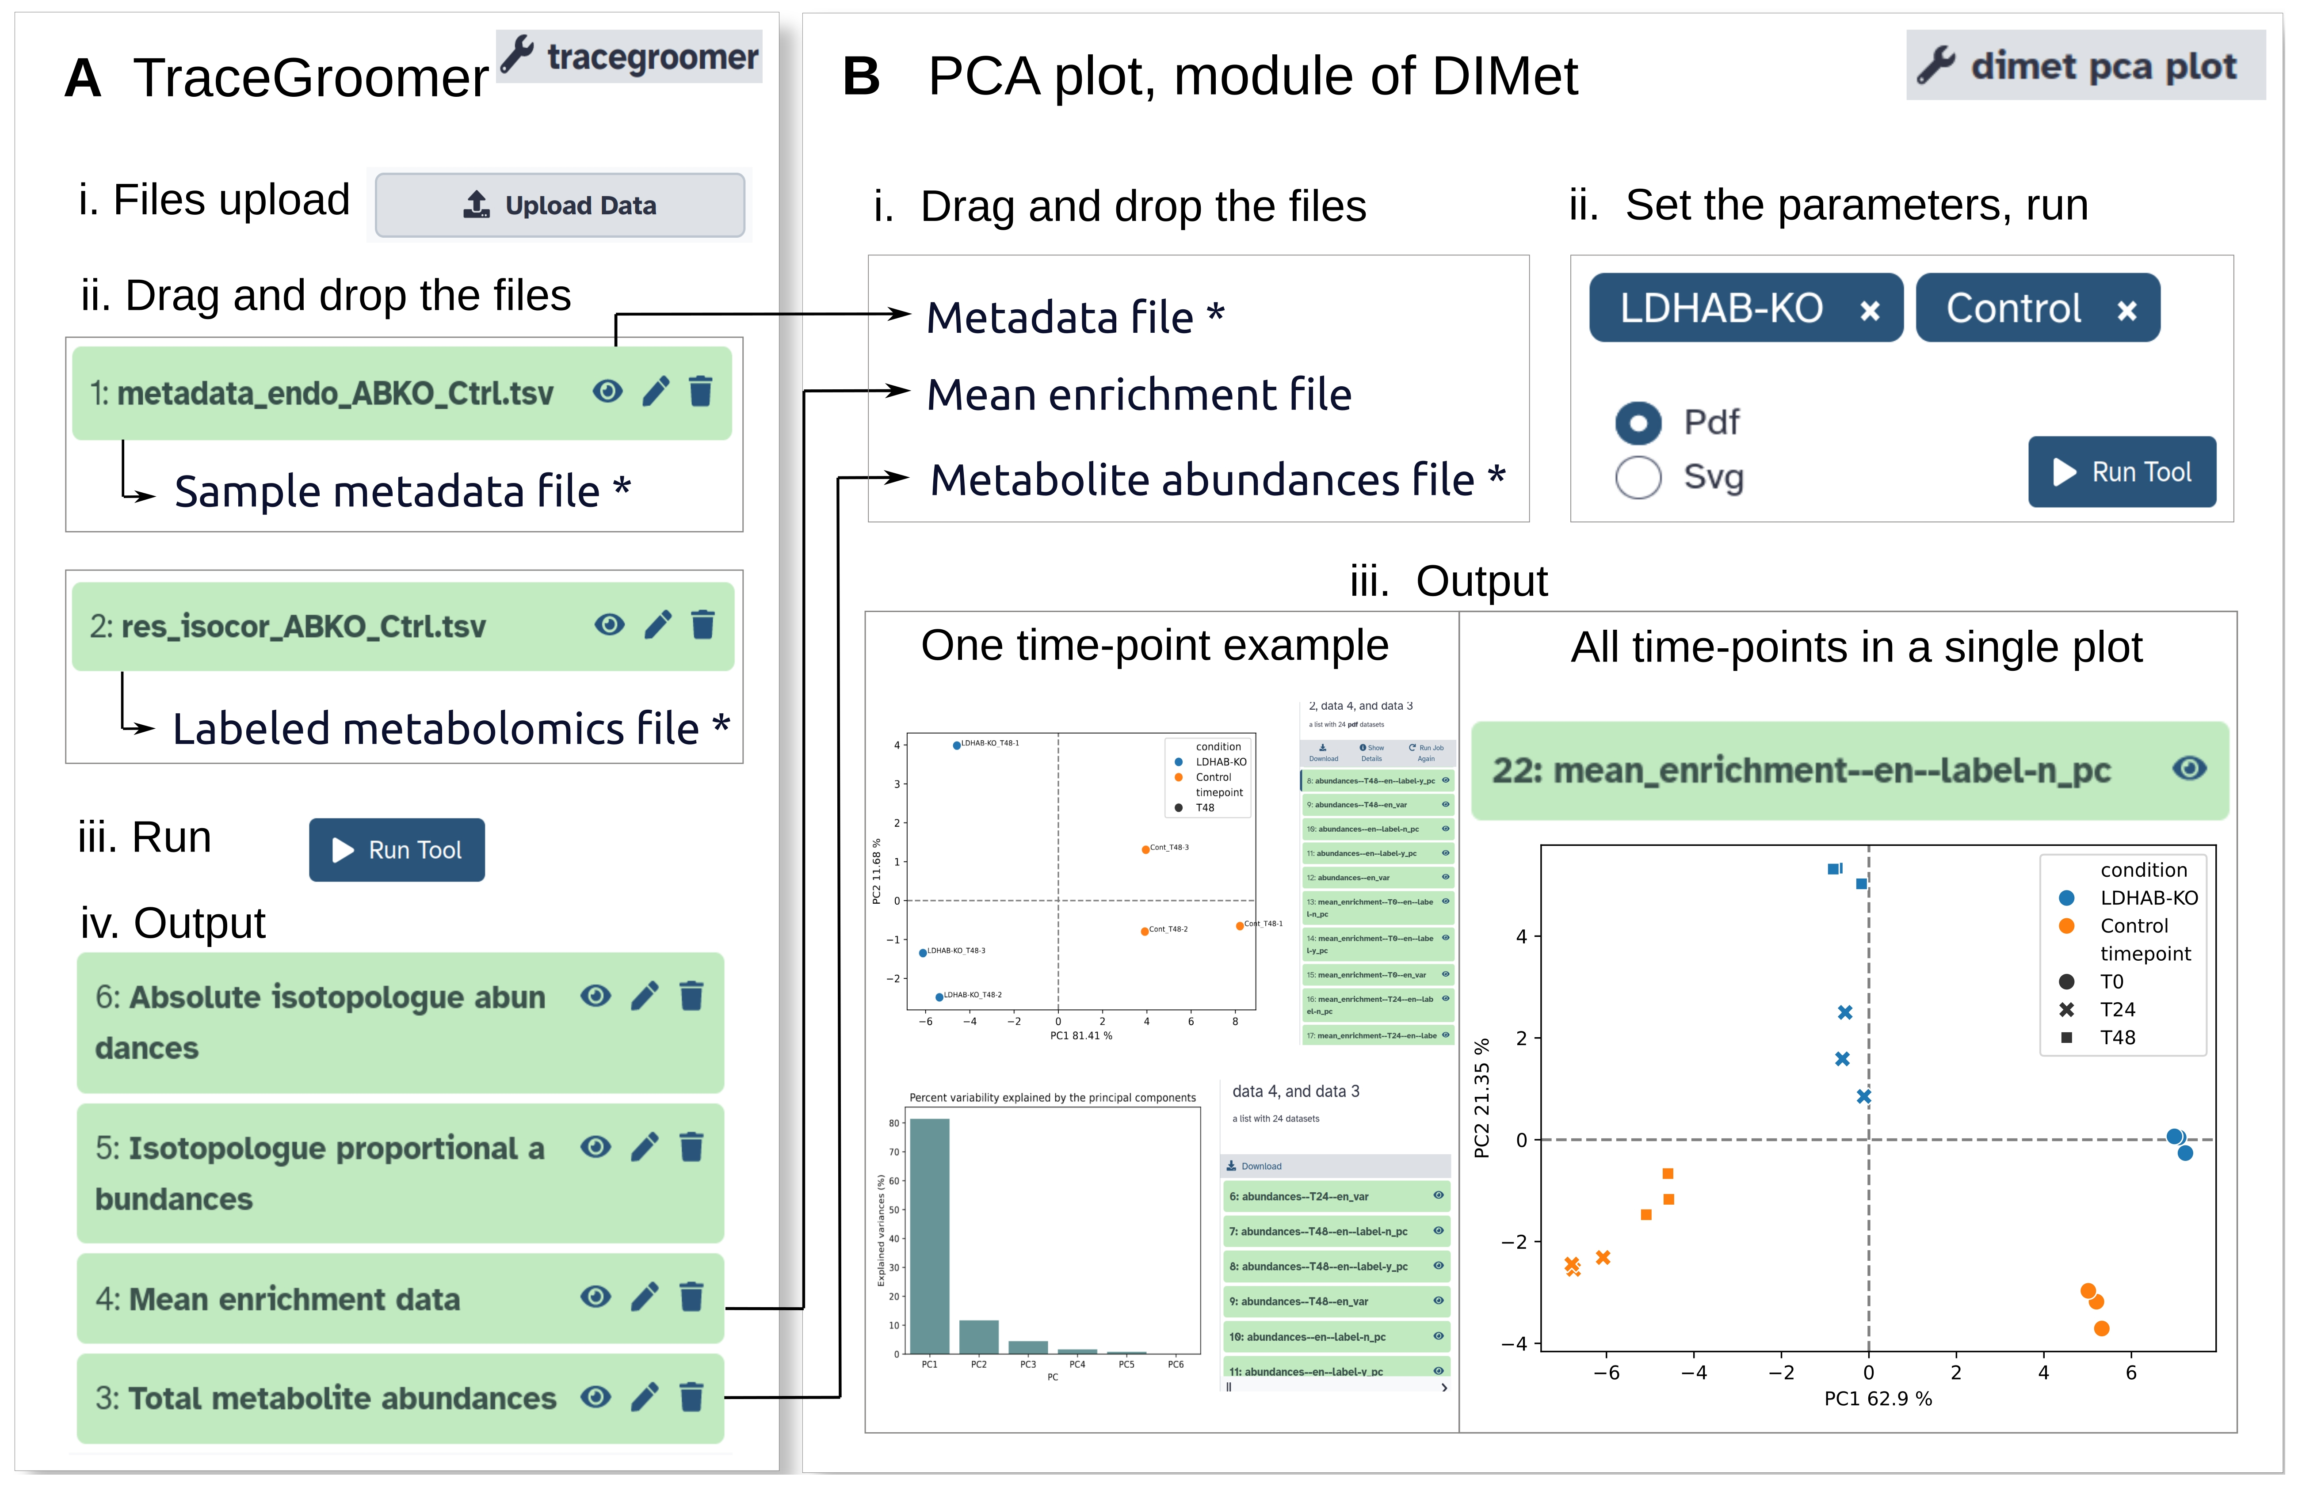

Figure 1 (example). Comprehensive but concise main title. A. Legend for panel A. B. Legend for panel B… (1) Use the preferred TIFF format with RGB color and ensure a 300–900 dpi resolution. Provide additional TIFF image files if using vector graphics in the manuscript. (2) DO NOT use layers or a transparent background and avoid red-green combinations. Avoid large blank spaces within the figure. (3) Label figure panels with A, B, C, … and include a legend for each panel. All text included in the figures, including panel labels, should be in 8–12 point font to ensure it is readable. (4) In the legend, include all information needed to understand the image without having to refer to the main text (e.g., define all abbreviations and symbols used). Define error bars, statistical tests, and labeled scale bars. Example from Galvis et al. (https://bio-protocol.org/en/bpdetail?id=5168&type=0&searchid=BP1736436306754353&sort=0).

Table 1. Comprehensive but concise main title. Legend. (1) Always use the Microsoft Word table function to prepare tables (DO NOT provide tables as images). (2) Do not use color or shading. (3) Include heading labels and borders in all columns. (4) If tables are too large, include them as a supplementary file; there are no limits on table size.
Column heading 1 | Column heading 2 | Column heading 3 | Column heading 4
xxx* | xxx | xxx | xxx
xxx | xxx | xxx | xxx
xxx | xxx | xxx | xxx
xxx | xxx | xxx | xxx
* Table footer.

[Video 1]

Video 1. Comprehensive but concise main title. Legend. Include all information needed to understand the video without having to refer to the main text (e.g., define all abbreviations and symbols used).

B. Other formatting notes

1. Use the following formats for special symbols and units where applicable (Table 2)

Table 2. Special symbols and units for experimental protocols
Symbol name | Symbol
Degree Celsius | X °C (with space between unit and numeral)
Micro | μ
Alpha | α
Beta | β
Gamma | γ
Less than or equal to | ≤
More than or equal to | ≥
Multiplication | ×
Chemical formula | MgSO₄·7H₂O
Prime | ′
Liter | L (mL, μL)
Exponentials | Y^{x}
Scientific notation | Y × 10^{x}
Centrifugation | X× g
Hyphen indicating range (en dash) | 1–3

2. Scientific nomenclature
The use of standard scientific nomenclature is required. Species, genes, genotypes, and mutations should be italicized. Genetic databases for the species of interest should be consulted to ensure that the recommended names are used. Bio-protocol encourages authors to refer to organisms by their common name (if a common name applies) and to provide the Latin name in parentheses at first use. Authors should determine whether the nomenclature they have used conforms to accepted community standards.

3. Code
If your protocol contains code, please use 9.5 point Courier New font and follow the format below.

Results$BckgCorrect <- rep(0, dim(Results)[1])
for (i in 1 :dim(Results)[1]) {
Bkgnd <- Results$Conditions == "Background" & Results$Exposure ==
}
…
4. Input
Describe the input format for the data (variables and types) (e.g., tab-delim/.txt file, with four columns, with/without header, etc.).
If the protocol includes metadata, describe the input format for the metadata (variables and types).

5. Output
Describe the expected output (e.g., DataFrame, list, result of a statistical test, type of graph, etc.).

6. Software
If your protocol contains instructions for a computer interface, please italicize (instead of using quotation marks) all menu/boxes/button names (e.g., "Begin the analysis by going to Automate → Project scripts… and clicking on Detection script”).

C. Procedure steps for the wet-lab component of the protocol

For each step, include all necessary details for materials and reagents used (e.g., volume added, specific container/tube, and incubation time) and the conditions in which the step was performed (e.g., temperature, agitation speed, and equipment settings); avoid using vague terms such as “several,” “enough,” “about,” or “around”). Use consistent nomenclature for all materials/reagents throughout the manuscript and do not repeat vendor/manufacturer and catalog number information in the text, unless in case of ambiguity. Be as detailed and clear as possible.
Note: You may use specific labels and notes immediately below the relevant step (see an example here).
1. Caution: Use when marking steps describing safety concerns. Provide details immediately below.
2. Pause point: Use when marking steps where the protocol can be stopped. Explain immediately below.
3. Critical: Use when marking critical steps. Explain why immediately below.

Result interpretation
Note: This section should provide an interpretation of the data obtained above.

Validation of protocol

This section aims to ensure readers that the protocol has been tested and can produce reliable results. You may provide evidence that the protocol is robust and reproducible by:

1. Providing data directly in this section. For experimental protocols, include information about the number of replicates, statistical tests applied, and controls used. If the Data Analysis section already provides sufficient validation information, briefly reference it here.
2. Referencing specific data published elsewhere. Cite figures, tables, or supplementary materials from the research article or preprint where the protocol was used (e.g., your original work). Use the following template:

This protocol (or parts of it) has been used and validated in the following research article(s):
- Author et al. [Reference number] Title of the research article. Journal name (Figure x, panel y).

Note: We highly encourage authors to provide validation data directly in this section while also citing data published elsewhere, particularly if the original research work is not open access.

General notes and troubleshooting

General notes

1. Include comments and tips that apply broadly to the protocol and not only to individual steps, and that are not fundamental to completing a specific step. Notes that are relevant to only one step or section should be included next to where they are relevant and labeled as Note (see step A1.ii of the Procedure).
2. General notes might address the limitations of the protocol, its applicability to other experimental systems and model organisms, or sources of variability.
3. If one of the General Notes is also relevant to a particular step, reference it by number after the step (e.g., “see General Note 1”).

Troubleshooting

Note: State common problems that might occur and describe ways to address them.

Problem 1: xxxxxxxx.
Possible cause: xxxxxxxx.
Solution: xxxxxxxx.

Problem 2: xxxxxxxx.
Possible cause: xxxxxxxx.
Solution: xxxxxxxx.

Supplementary information

Note: Reference all supplementary information in the main text as “Dataset S1,” “Code S1,” “Figure S1,” or “Table S1.” Supplementary information can be submitted as a ZIP file.

The following supporting information can be downloaded here (link available when this protocol is published online):
1. Dataset S1. title
2. Code S1. title
3. Figure S1. title
4. Table S1. Title

Acknowledgments

Include the following mandatory information: 1) Specific contributions of each author, e.g., Conceptualization, X.X.; Investigation, X.X. Writing—Original Draft, X.Y.; Writing—Review & Editing, X.X.; Funding acquisition, X.X.; Supervision, X.X. 2) Funding sources that supported the work. 3) Citation of the original research paper in which the protocol was described and validated, if applicable. 4) Acknowledgment of any previous work from which the protocol was developed, modified, or derived; this can include the author's own prior research or work by other researchers.

Competing interests

The corresponding author should provide a statement of financial and non-financial competing interests on behalf of all authors. Examples include paid employment or consultancy, stock ownership, patent applications, personal relationships with individuals involved in the submission or evaluation of a protocol, and receipt of funding or free products from the vendors of the reagents/equipment or other advertisers. For more information, see our guidelines for disclaiming competing interests here. Add a competing interests section even if there are no competing interests, writing “The authors declare no conflicts of interest.”

Ethical considerations

All protocols that have used human and/or animal subjects must mention the specific ethics committee that approved the described experiment. This information should also be added to any relevant figure or video legends.
Protocols including human subjects should also indicate that informed consent was obtained from all subjects. Protocols including clinical trials should clearly state the name of the trial registry and the clinical trial registration number in the manuscript. For animal research, we recommend following the guidelines established in (ARRIVE).
For more information, see our publishing ethics notes.

References

      - Author 1, F. M., Author 2, F. M., …, Author 10, F. M., et al. (Year). Title of the article. Journal Abbreviation. Volume (issue): Firstpage–Lastpage. https://doi.org/doinumber.
      - Author 1, F. M., Author 2, F. M., …, Author 10, F. M., et al. (Year). (Chap. xx: optional) Title of the article. In Editor 1, Editor 2 and Editor 3 (Ed/Eds). Book Name. Publisher name, City (optional), Firstpage–Lastpage. http://URL
      - Author 1, F. M., Author 2, F. M., …, Author 10, F. M., et al. (Year). Title of the book. Publisher name, City (optional), ISBN (optional): ISBN number. http://URL
      - Author 1, F. M., Author 2, F. M., …, Author 10, F. M., et al. (Year). Title of the article. Conference name, Conference organizer, Location, Date.
      - Author (if available). Title of Webpage (if available). (Accessed on Month Day, Year, http://URL).
      - Creator (if available) (Year). Title of the Software, version, revision or edition (if available); Publisher: Place of Publication. http://URL
      - Author 1, F. M. (Year). Title of Thesis. Dissertation. University name. http://URL
      - Author 1, F. M., Author 2, F. M., …, Author 10, F. M., et al. (Year). Title of the Unpublished Work. Status (manuscript in preparation; to be submitted)
      - Author 1, F. M., Author 2, F. M., Author 3, F. M., et al. (Year). Title of Unpublished Work. Abbreviated Journal Name, phrase indicating stage of publication (submitted; accepted; in press).
      - Patent Owner 1; Patent Owner 2; et al. Title of Patent. Patent Number, Date (Month Day, Year, the Application granted date).

