**How to use this template**

1. Click [here](https://bio-protocol.org/en/bpdetail?id=4936&type=0) to see an example of an article in the standard *Bio-protocol* format.
2. Prepare your manuscript using Microsoft Word by filling in the template below, using the format styles presented for each section. Our manuscript template **does not accept** any color or shading in the text.
3. Delete this section and start with the “Title” on the next page, replacing the text of each section with your content. Delete all notes with instructions.
4. Do not change the format of any level 1 section headings. Please note that the following sections are required:

Key features

Keywords

Abstract

Background

Materials and reagents

Procedure

**Validation of protocol**

Acknowledgments

Competing interests

References

1. Format all in-text citations as reference numbers (e.g., “The protocol described here was based on previous works [1]”). All manuscripts must use the *Bio-protocol* referencing style, which can be found via [EndNote](https://endnote.com/style_download/bio-protocol/) or CSL reference manager tools such as [Zotero](https://www.zotero.org/styles?q=bio-protocol). You can also use the direct link from [GitHub](https://github.com/citation-style-language/styles/blob/master/bio-protocol.csl). When citing multiple sources, the numbers should be separated by a comma or a dash, for example, [1,3,5] or [1–3]. Note that references must be cited in sequential order throughout the text.

Protocol Title -- for experimental protocol

Author 11, #, §, Author 21, 2, $, #, Author 32, and Author 42, *

1Dept/Center, Institution name, City, Country

2Dept/Center, Institution name, City, Country

$Current/Present address: Dept/Center, Institution name, City, Country

*For correspondence: email address

#[not required] Contributed equally to this work

§[not required] Technical contact: email address

Abstract

Introduce the research field (1–2 sentences), provide context by mentioning other existing and previously used techniques (1–2 sentences), summarize the protocol (3–4 sentences), and finish by summarizing the advantages of the protocol presented (1–2 sentences). Do not include references (e.g., to articles or figures) in the Abstract.

# Key features

* Add up to four Key Features, each with a maximum of 25 words (click [here](https://bio-protocol.org/en/bpdetail?id=5072&type=0) for an example).
* Key Features should convey the most important elements of your protocol and not simply repeat or condense ideas expressed in the Abstract.
* They should highlight characteristics that will allow readers to determine whether the protocol is relevant to their work.
* For example, they might mention experimental contexts in which the protocol was developed and is most useful.

# Keywords: Keyword 1, Keyword 2, Keyword 3, … (5–8 in total)

**This protocol is used in:** Journal Name (Year), DOI: xxxxx

*Cite the original article(s) where this protocol was used/validated (only relevant if you have articles listed in the validation section).*

# Graphical overview

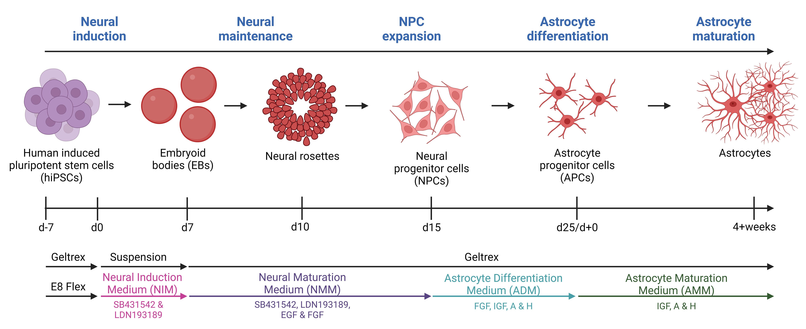

**Include a figure title for clarity. The graphical overview is highly recommended but not required. Provide a graphical overview of the procedure in figure format, either as a flowchart of the method/procedures or a highlight of key steps. Minimize the use of text in the graphical overview and ensure all text, numbers, or symbols are readable. Be sure to distribute the content evenly in the figure and avoid large blank spaces. The graphical overview should not be identical to any other figure in the article and should not be a simple combination of a large paragraph of text and an image. All figures should be high resolution (300–900 dpi) and created in one of the following formats: PNG, JPEG, SVG, PSD, or TIFF. See more information below and on the author guidelines page here.** [Example from Dittlau et al. (2024)](https://bio-protocol.org/en/bpdetail?id=4936&type=0&searchid=BP1714986275069162&sort=0)**.**

# Background

Briefly introduce the research area that your protocol can be used to advance. Discuss previously described related methodologies and summarize the advantages and limitations of using your protocol over other published methods. If applicable, elaborate on other possible applications of the protocol.

# Materials and reagents

*Note: Ensure you include all and only the items used in the protocol and organize them according to the categories below. Information on vendor/manufacturer and catalog number is mandatory. Provide storage information (i.e., temperature and shelf-life) for critical reagents or as appropriate. Provide references or instructions to acquire or generate custom-made materials, reagents, or equipment (see the section below). Use consistent nomenclature throughout the manuscript.*

Biological materials

1. Bacterial strain name 1 (Manufacturer, catalog number/origin: XXX)

2. Virus strains name 1 (Manufacturer, catalog number/origin: XXX)

3. Cell line name 1 (Manufacturer, catalog number/origin: XXX)

4. Biological samples 1 (Manufacturer, catalog number/origin: XXX)

5. …

**Reagents**

1. Product 1 name (Manufacturer, catalog or CAS number: XXXX)

2. …

**Solutions**

1. Solution name 1 (abbreviation, if applicable) (see Recipes)

2. …

**Recipes**

*Note: Be precise about the ingredients (e.g., buffer or media), quantities, and conditions established for your experiments. Note that the omission of minor details from recipes (e.g., type of water used or storage conditions) might lead to the failure of the experiment.*

**1. Recipe name 1**

|  |  |  |
| --- | --- | --- |
| **Reagent** | **Final concentration** | **Quantity or Volume** |
| Reagent name 1 | xx mM | xx mL |
| Reagent name 2 | xx g/L | xx g |
| … | … | … |
| Total (optional) | n/a | xx mL |

**2. Recipe name 2**

|  |  |  |
| --- | --- | --- |
| **Reagent** | **Final concentration** | **Quantity or Volume** |
| Reagent name 1 | xx mM | xx mL |
| Reagent name 2 | xx g/L | xx g |
| … | … | … |
| Total (optional) | n/a | xx mL |

**Laboratory supplies**

1. Consumable name 1 (Manufacturer, catalog number: XXXX)

2. Consumable name 2 (Manufacturer, catalog number: XXXX)

3. …

# Equipment

1. Equipment 1 name (Manufacturer, catalog number/model: XXXX)

2. Equipment 2 name (Manufacturer, catalog number/model: XXXX)

3. …

# Software and datasets

*Note: List individual software or datasets required to complete the protocol, including version and release date. Provide references for items that are not commercially available. Note whether the software is free to use or requires a license (and detail the license needed) and, if possible, provide free alternatives to commercial software.*

1. Software 1 name (Manufacturer, Version)

2. Source (Link, Access date, Month/Day/Year)

3. All data and code have been deposited to GitHub: https://github.com/Bio-protocol/anchorwave_protocol (Access date, Month/Day/Year).

…

# Procedure

**A. Section title 1**

1. Write chronological, step-by-step instructions for the protocol. We recommend dividing the major steps of the protocol into separate sections (A, B, C, …) with descriptive subtitles.

2. Write steps as instructions using the active voice and present tense (e.g., "Prepare stock solutions and reaction mixtures under anaerobic conditions” instead of “Stock solutions and reaction mixtures were prepared under anaerobic conditions").

a. For each step, include all necessary details for materials and reagents used (e.g., volume added, specific container/tube, and incubation time) and the conditions in which the step was performed (e.g., temperature, agitation speed, and equipment settings); avoid using vague terms such as “several,” “enough,” “about,” or “around”). Use consistent nomenclature for all materials/reagents throughout the manuscript and do not repeat vendor/manufacturer and catalog number information in the text, unless in case of ambiguity. Be as detailed and clear as possible.

b. You may use specific labels and notes immediately below the relevant step (see an example [here](https://bio-protocol.org/en/bpdetail?id=4962&type=0)):

i. **Caution:** Use when marking steps describing safety concerns. Provide details immediately below.

ii. **Pause point:** Use when marking steps where the protocol can be stopped. Explain immediately below.

iii. **Critical:** Use when marking critical steps. Explain why immediately below.

iv. Note: Use when marking any other comments, suggestions, or recommendations relevant to a specific step.

Note: Notes that apply to the protocol more broadly and are not only relevant to a specific step or section should be added to the General notes and troubleshooting (see below).

v. See Troubleshooting: May be used to mark steps where troubleshooting information is available in the General Notes and Troubleshooting section (see below). This may be information on what to do if part or all of the protocol does not work, referencing specific steps, or noting what can be changed or optimized if particular outcomes happen.

3. Provide images (e.g., Figure 1), tables (e.g., Table 1), and videos (e.g., Video 1) for key steps, representative data (intermediate and final) to illustrate the type of results obtained, and notes/tips. Embed all figures and tables within the text, placing each one close to the first mention. Ensure figures, tables, and videos are numbered in the order they are referenced.

4. If special training is required to perform some steps or operate specific equipment, please note this in the protocol and consider mentioning it in the Key Features section as well.

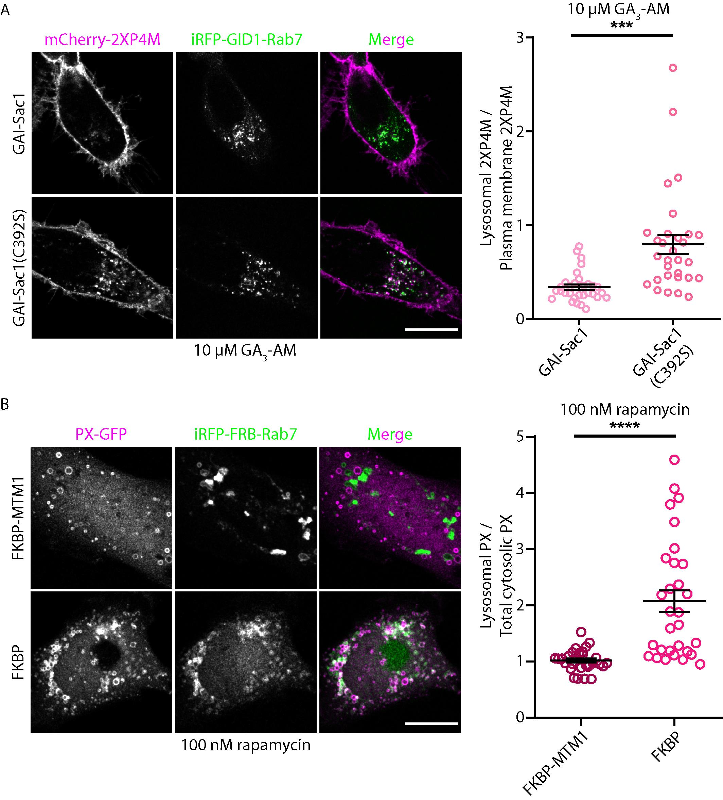

**Figure 1. Comprehensive but concise main title.** A. Legend for panel A. B. Legend for panel B… (1) Use the preferred TIFF format with RGB color and ensure a 300–900 dpi resolution. Provide additional TIFF image files if using vector graphics in the manuscript. (2) **DO NOT use layers or a transparent background** and avoid large blank spaces within the figure. (3) Label figure panels with A, B, C, … and include a legend for each panel. All text included in the figures, including panel labels, should be in 8–12 point font to ensure it is readable. (4) In the legend, include all information needed to understand the image without having to refer to the main text (e.g., define all abbreviations and symbols used). Define error bars, statistical tests, and labeled scale bars. (5) To ensure accessibility for all readers authors should use color combinations in their figures that are color deficiency friendly. For more information on appropriate color combinations, check <https://pmc.ncbi.nlm.nih.gov/articles/PMC8041175/> and <http://safecolours.rigdenage.com/palettefiles.html>. [Example from Yap et al. (2024)](https://bio-protocol.org/en/bpdetail?id=5078&type=0)**.**

**Table 1. Comprehensive but concise main title.** Legend. (1) Always use the Microsoft Word table function to prepare tables (DO NOT provide Tables as images). (2) Do not use color or shading. (3) Include heading labels and borders in all columns. (4) If Tables are too large, include them as a supplementary file; there are no limits on table size.

|  |  |  |  |
| --- | --- | --- | --- |
| **Column heading 1** | **Column heading 2** | **Column heading 3** | **Column heading 4** |
| xxx* | xxx | xxx | xxx |
| xxx | xxx | xxx | xxx |
| xxx | xxx | xxx | xxx |
| xxx | xxx | xxx | xxx |

* Table footer.

**[Video 1]**

**Video 1. Comprehensive but concise main title.** Legend. Include all information needed to understand the video without having to refer to the main text (e.g., define all abbreviations and symbols used).

**B. Other formatting notes**

1. Use the following formats for special symbols and units where applicable (Table 2)

**Table 2. Special symbols and units**

|  |  |
| --- | --- |
| **Symbol name** | **Symbol** |
| Degree Celsius | X °C (with space between unit and numeral) |
| Micro | μ |
| Alpha | α |
| Beta | β |
| Gamma | γ |
| Less than or equal to | ≤ |
| More than or equal to | ≥ |
| Multiplication | × |
| Chemical formula | MgSO4·7H2O |
| Prime | ′ |
| Liter | L (mL, μL) |
| Exponentials | Yx |
| Scientific notation | Y × 10x |
| Centrifugation | X× *g* |
| Hyphen indicating range (en dash) | 1–3 |

2. Scientific nomenclature

The use of standard scientific nomenclature is required. Species, genes, genotypes, and mutations should be italicized. Genetic databases for the species of interest should be consulted to ensure that the recommended names are used. Bio-protocol encourages authors to refer to organisms by their common name (if a common name applies) and to provide the Latin name in parentheses at first use. Authors should determine whether the nomenclature they have used conforms to accepted community standards.

3. Code

If your protocol contains code, please use 9.5 point Courier New font and follow the format below.

Results$BckgCorrect <- rep(0, dim(Results)[1])

for (i in 1 :dim(Results)[1]) {

Bkgnd <- Results$Conditions == "Background" & Results$Exposure ==

}

…

4. Software

If your protocol contains instructions for a computer interface, please italicize (instead of using quotation marks) all menu/boxes/button names (e.g., "Begin the analysis by going to *Automate* → *Project scripts…* and clicking on *Detection script*”).

# Data analysis

Provide a detailed description of data processing and analyses: include statistical tests, criteria for data inclusion/exclusion, and details on the recommended number of biological and technical replicates for each experiment. Highlight any specific skills necessary to perform the analyses (e.g., expertise using Linux, R) and any specific analysis software.

When a detailed description of the data analysis method already appears in sufficient detail in a published or posted research article, summarize the analysis method and cite the publication or preprint. Please indicate clearly where the description of the analysis can be found (e.g., Supplemental information or Figure X).

# Validation of protocol

This section aims to ensure readers that the protocol has been tested and can produce reliable results. You may provide evidence that the protocol is robust and reproducible by:

**1. Providing data directly in this section**. For experimental protocols, include information about the number of replicates, statistical tests applied, and controls used. If the Data Analysis section already provides sufficient validation information, briefly reference it here.

**2. Referencing specific data published elsewhere**. Cite figures, tables, or supplementary materials from the research article or preprint where the protocol was used (e.g., your original work). Use the following template:

This protocol (or parts of it) has been used and validated in the following research article(s):

* Author et al. [Reference number] Title of the research article. Journal name (Figure x, panel y).

*Note*: *We highly encourage authors to provide validation data directly in this section while also citing data published elsewhere, particularly if the original research work is not open access.*

# General notes and troubleshooting

**General notes**

1. Include comments and tips that apply broadly to the protocol and not only to individual steps, and that are not fundamental to completing a specific step. Notes that are relevant to only one step or section should be included next to where they are relevant and labeled as *Note* (see step 1.2.2 of the procedure).

2. General notes might address the limitations of the protocol, its applicability to other experimental systems and model organisms, or sources of variability*.*

3. If one of the General Notes is also relevant to a particular step, reference it by number after the step (e.g., “see General Note 1”).

**Troubleshooting**

*Note: State common problems that might occur and describe ways to address them.*

Problem 1: xxxxxxxx.

Possible cause: xxxxxxxx.

Solution: xxxxxxxx.

Problem 2: xxxxxxxx.

Possible cause: xxxxxxxx.

Solution: xxxxxxxx.

# Supplementary information

*Note: Reference all supplementary information in the main text as “Dataset S1,” “Figure S1,” or “Table S1.” Supplementary information can be submitted as a Zip file.*

The following supporting information can be downloaded here (link available when this protocol is published online):

1. Dataset S1. title

2. Figure S1. title

3. Table S1. title

# Acknowledgments

Include the following mandatory information: 1) Specific contributions of each author, e.g., Conceptualization, X.X.; Investigation, X.X. Writing—Original Draft, X.Y.; Writing—Review & Editing, X.X.; Funding acquisition, X.X.; Supervision, X.X. 2) Funding sources that supported the work. 3) Citation of the original research paper in which the protocol was described and validated, if applicable. 4) Acknowledgment of any previous work from which the protocol was developed, modified, or derived; this can include the author's own prior research or work by other researchers.

# Competing interests

The corresponding author should provide a statement of financial and non-financial competing interests on behalf of all authors. Examples include paid employment or consultancy, stock ownership, patent applications, personal relationships with individuals involved in the submission or evaluation of a protocol, and receipt of funding or free products from the vendors of the reagents/equipment or other advertisers. For more information, see our guidelines for disclaiming competing interests [here](https://bio-protocol.org/en/authors?type=interests). Add a competing interests section even if there are no competing interests, writing “The authors declare no conflicts of interest.”

# Ethical considerations

All protocols that have used human and/or animal subjects must mention the specific ethics committee that approved the described experiment. This information should also be added to any relevant figure or video legends.

Protocols including human subjects should also indicate that informed consent was obtained from all subjects. Protocols including clinical trials should clearly state the name of the trial registry and the clinical trial registration number in the manuscript. For animal research, we recommend following the guidelines established in ([ARRIVE](https://pubmed.ncbi.nlm.nih.gov/20613859/)).

For more information, see our [publishing ethics notes](https://bio-protocol.org/en/authors?type=ethics).

# References

* + - 1. Author 1, F. M., Author 2, F. M., …, Author 10, F. M., et al. (Year). Title of the article. *Journal Abbreviation.* Volume (issue): Firstpage–Lastpage. <https://doi.org/doi>number.
      2. Author 1, F. M., Author 2, F. M., …, Author 10, F. M., et al. (Year). (Chap. xx: optional) Title of the article. In Editor 1, Editor 2 and Editor 3 (Ed/Eds). *Book Name*. Publisher name, City (optional), Firstpage–Lastpage. http://URL
      3. Author 1, F. M., Author 2, F. M., …, Author 10, F. M., et al. (Year). *Title of the book.* Publisher name, City (optional), ISBN (optional): ISBN number. http://URL
      4. Author 1, F. M., Author 2, F. M., …, Author 10, F. M., et al. (Year). Title of the article. Conference name, Conference organizer, Location, Date.
      5. Author (if available). Title of Webpage (if available). (Accessed on Month Day, Year, <http://URL>).
      6. Creator (if available) (Year). *Title of the Software*, version, revision or edition (if available); Publisher: Place of Publication. http://URL
      7. Author 1, F. M. (Year). Title of Thesis. Dissertation. University name. http://URL
      8. Author 1, F. M., Author 2, F. M., …, Author 10, F. M., et al. (Year). Title of the Unpublished Work. Status (manuscript in preparation; to be submitted)
      9. Author 1, F. M., Author 2, F. M., Author 3, F. M., et al. (Year). Title of Unpublished Work. Abbreviated Journal Name, phrase indicating stage of publication (submitted; accepted; in press).
      10. Patent Owner 1; Patent Owner 2; et al. Title of Patent. Patent Number, Date (Month Day, Year, the Application granted date).