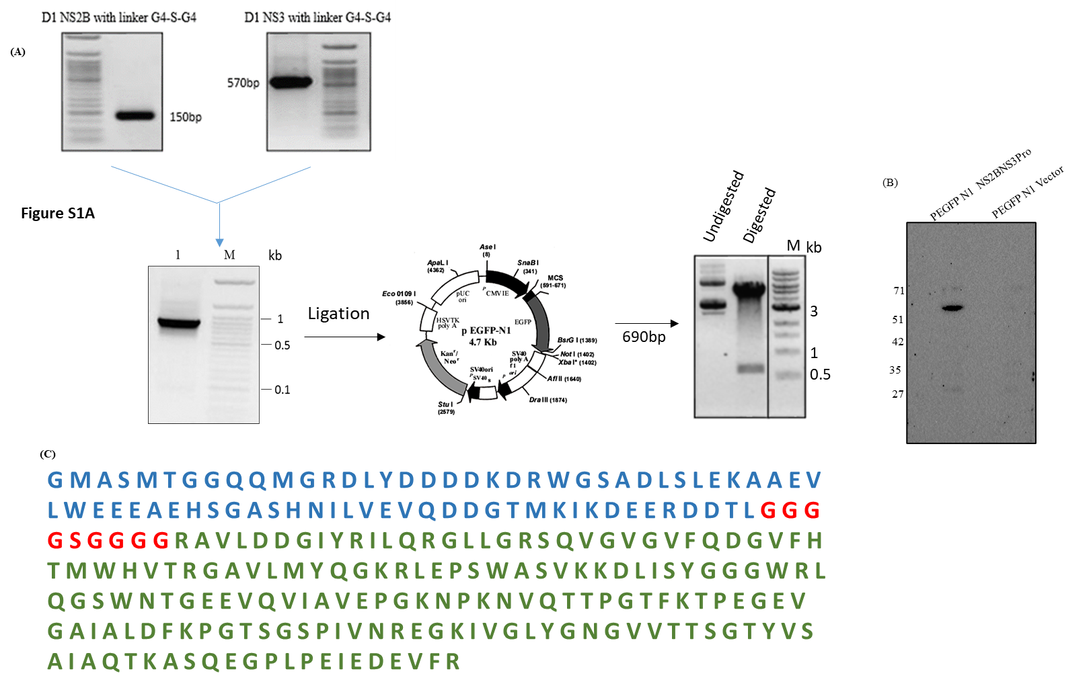
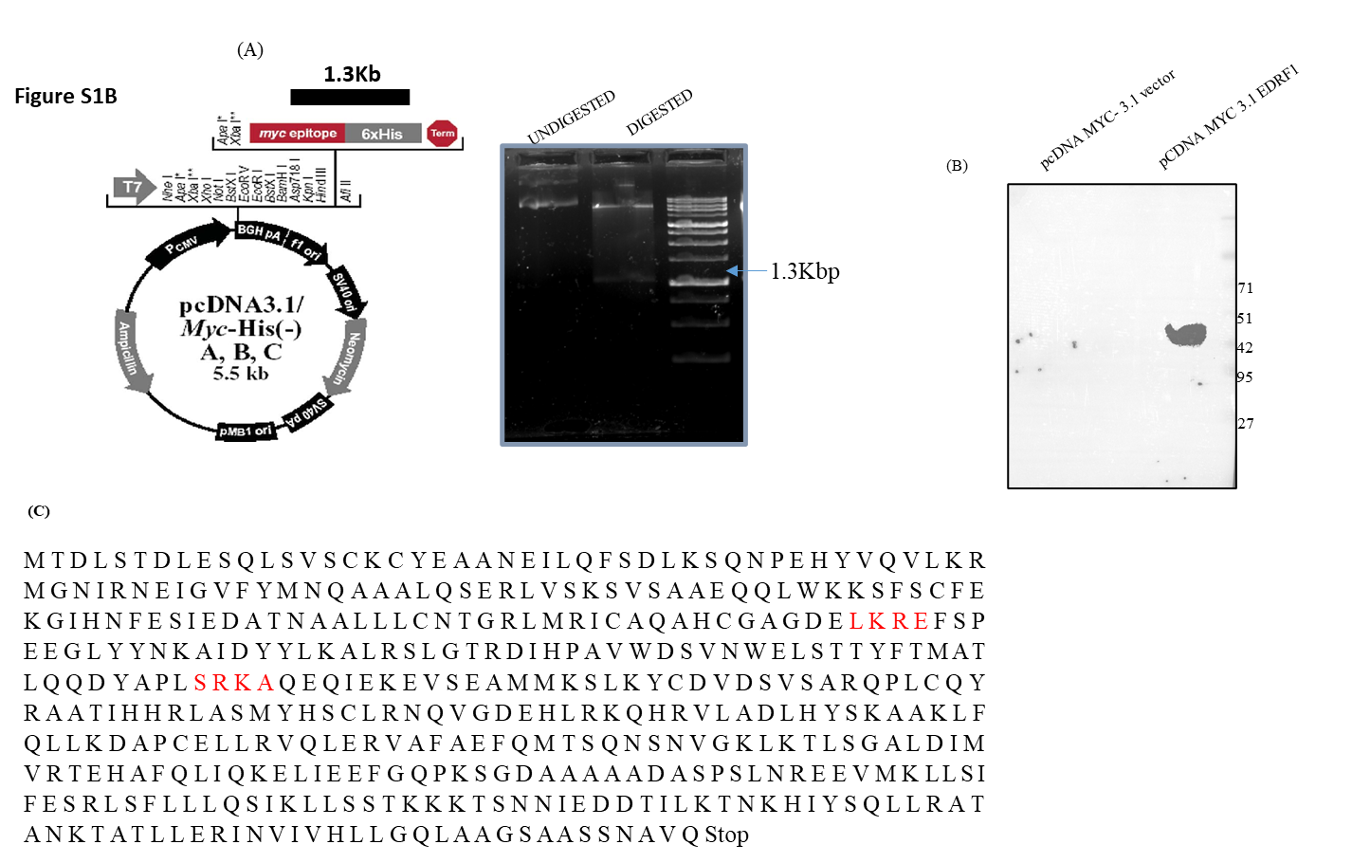
Figure S1A: Cloning and expression of DENV protease in ex vivo. A) Amplification, ligation and confirmation of protease insert. B) Western blotting of the transfected cell lysate with anti-protease antibodies and C) Protease amino acid sequence cloned.
Figure S1B: Cloning and expression of EDRF1 in ex vivo. A) Amplification, ligation and confirmation of EDRF1 insert. B) Western blotting of the transfected cell lysate with anti-EDRF1 antibodies and C) EDRF1 amino acid sequence cloned.

