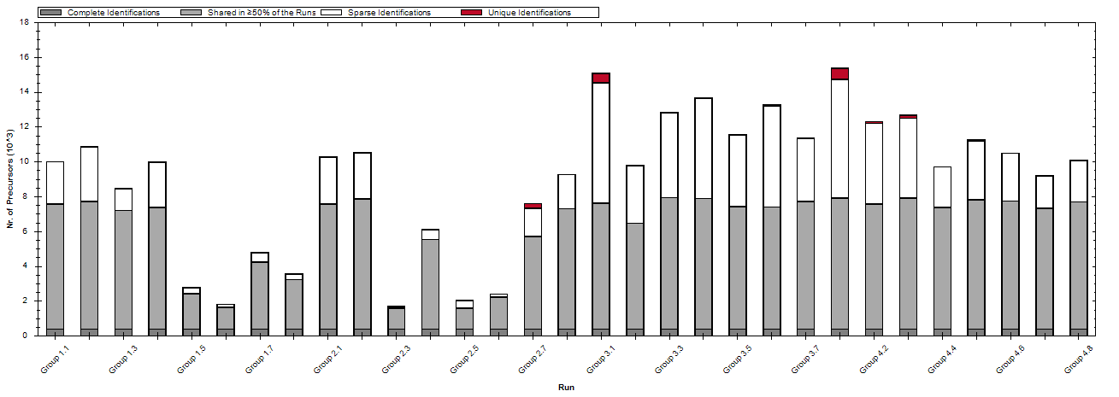
Supplementary Figure 1. Distribution of precursor identifications across thirty-one CSF samples.
Raw data were processed and analyzed using the Spectronaut®/DirectDIA (Biognosys) workflow with default settings. As shown, samples with Group ID 1.5, 1.6, 1.7, 1.8, 2.3, 2.5, and 2.6 exhibited substantially fewer precursor identifications compared to the other samples. Based on this quality control (QC) assessment, these samples were deemed low quality based on QC metrics and were excluded from subsequent data analysis.

Supplementary Table 1. Protein identifications and sample group information for thirty-one rat cerebrospinal fluid (CSF) samples
Group | Group ID | Protein identified | Sample ID
1 | Group 1.1 | 854 | Sample 16
1 | Group 1.2 | 843 | Sample 17
1 | Group 1.3 | 771 | Sample 18
1 | Group 1.4 | 838 | Sample 19
1 | Group 1.5 | 485 | Sample 20
1 | Group 1.6 | 395 | Sample 21
1 | Group 1.7 | 568 | Sample 22
1 | Group 1.8 | 488 | Sample 23
2 | Group 2.1 | 868 | Sample 24
2 | Group 2.2 | 814 | Sample 25
2 | Group 2.3 | 407 | Sample 26
2 | Group 2.4 | 636 | Sample 27
2 | Group 2.5 | 492 | Sample 28
2 | Group 2.6 | 269 | Sample 29
2 | Group 2.7 | 824 | Sample 30
2 | Group 2.8 | 786 | Sample 31
3 | Group 3.1 | 1171 | Sample 1
3 | Group 3.2 | 856 | Sample 2
3 | Group 3.3 | 1072 | Sample 3
3 | Group 3.4 | 1065 | Sample 4
3 | Group 3.5 | 1044 | Sample 5
3 | Group 3.6 | 1105 | Sample 6
3 | Group 3.7 | 847 | Sample 7
4 | Group 4.1 | 996 | Sample 8
4 | Group 4.2 | 1101 | Sample 9
4 | Group 4.3 | 1068 | Sample 10
4 | Group 4.4 | 736 | Sample 11
4 | Group 4.5 | 822 | Sample 12
4 | Group 4.6 | 797 | Sample 13
4 | Group 4.7 | 743 | Sample 14
4 | Group 4.8 | 784 | Sample 15
Note: Samples highlighted in the table were considered low quality based on quality control (QC) metrics and were excluded from subsequent data analysis.

