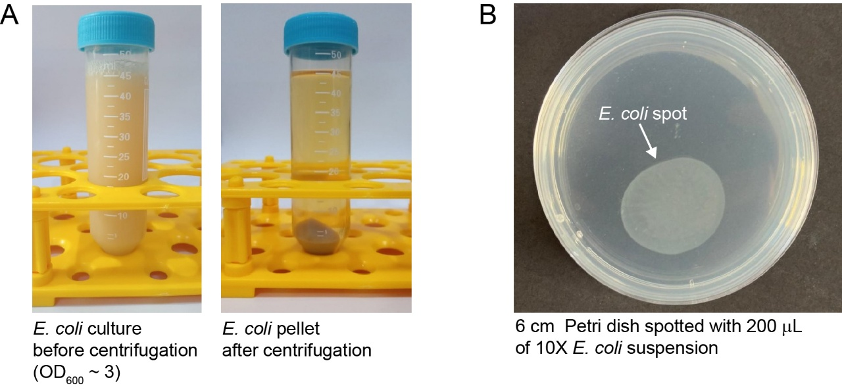

Supplementary Figure 1. (A) 45 mL of E. coli OP50 ON culture before (left) and after centrifugation. This corresponds to half of the ON culture volume. (B) 6 cm, maintenance Petri dish inoculated with 200 μL of 10X E. coli OP50 slurry and dried ON. The 10X suspension is made by resuspending the E. coli pellet from Panel A (right) in 4.5 mL of M9 medium.

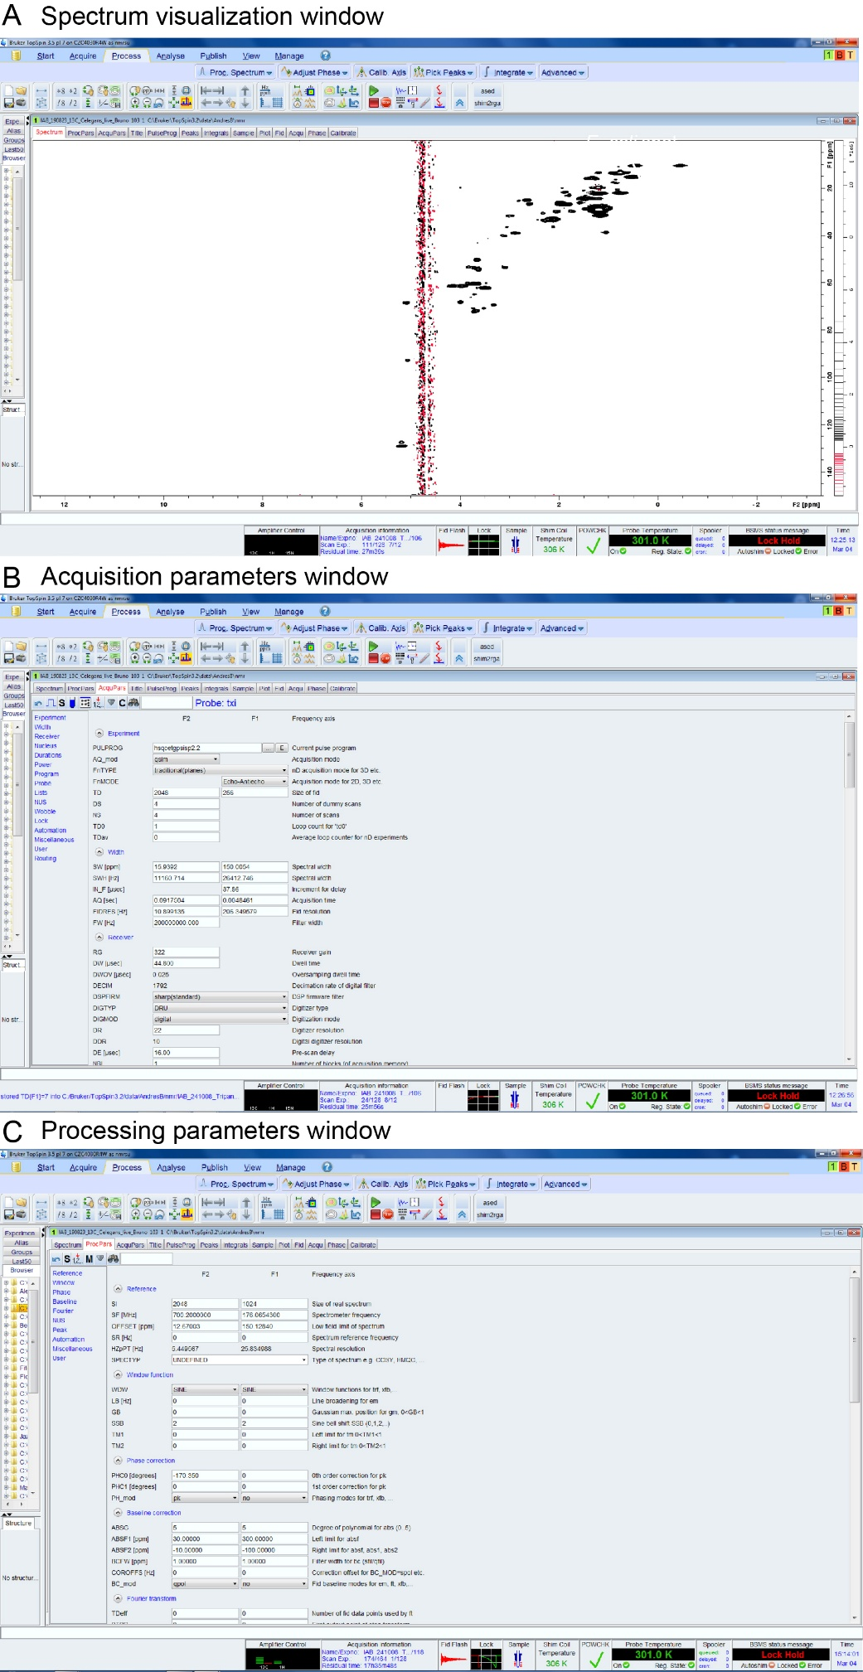

Supplementary Figure 2. Screenshots of the spectrum visualization, acquisition and processing parameters of Topsin 3.5 (Bruker, BioSpin)
Supplementary Table 1. NMR signal assignments of chemical groups from lipid classes found in C. elegans lipid extracts
Chemical group – lipid class | ¹H c.s. (ppm) | ¹³C c.s. (ppm)
CH₂-CFA^{c} | -0.34 | 10.95
CH₂-CFA^{t} | 0.56 | 10.95
CH-CFA^{cp} | 0.66 | 15.76
CH₃-FA | 0.88 | 14.22
CH₃-FA UFA(n-3) | 0.97 | 14.24
CH₂-CFA | 1.14 | 28.77
(CH₂)_{n}-FA | 1.28 | 29.69
CH₂-CFA | 1.52 | 29.74
CH₂CH₂O-FA | 1.61 | 24.89
Δ-1CH₂-UFA | 2.03 | 27.29
CH₂O-FA | 2.31 | 34.16
Δ-CH₂-Δ-PUFA | 2.82 | 25.72
CH₂NH₃-PE | 3.17 | 40.56
N(CH₃)₃-PC | 3.32 | 54.73
CH₂OR-DAG | 3.73 | 61.58
CH₂N(CH₃)₃-PC | 3.78 | 66.68
CH₂OP-PL | 3.98 | 63.97
CH₂OR-PL | 4.10 | 62.36
CH₂OR-PL | 4.38 | 62.55
CH₂CH₂NH₃-PE | 4.14 | 62.32
CH₂OR-TAG | 4.15 | 62.26
CH₂OR-TAG | 4.29 | 62.18
CH₂CH₂N(CH₃)3-PC | 4.38 | 59.54
CHOR-DAG | 5.14 | 71.67
CHOR-PL | 5.21 | 70.27
CHOR-TAG | 5.28 | 68.92
CH=CH(MUFA + PUFA) | 5.37 | 129.85
CH=CH(PUFA) | 5.39 | 128.11
Abbrevaitions: c.s. chemical shifts, CFA, cyclic fatty acids; FA, fatty acids; UFA, unsaturated fatty acids; PUFA, polyunsaturated fatty acids; PE, phosphoethanolamine; PC, phosphatidylcholine; PL, phospholipids; DAG, diacyl glyceride; TAG, triacyl glyceride; MUFA, monounsaturated fatty acids.
^{c}cis-proton of cyclopropane in CFA; ^{t}trans-proton of cyclopropane in CFA; ^{cp}cyclopropane in CFA.
Chemical shift from lipid extracts can be transferred to in vivo samples after spectra calibration. Chemical shifts from charged lipid groups (polar heads of PL, PE and PC) might present small perturbations due to varying experimental conditions, e.g. pH or ionic strength, during the extraction procedure.

