Supplementary information

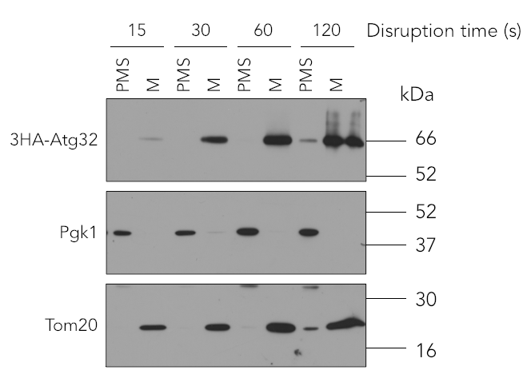

Figure S1. Optimization of Cell Disruption. To optimize cell disruption, cell suspensions were subjected to different vortexing cycles (15, 30, 60, and 120 seconds) with each cycle repeated three times and separated by 30 s incubation on ice. Samples were subsequently analyzed by Western blot. Our results indicate that disruption times of 30 and 60 seconds are sufficient to obtain mitochondrial fractions of adequate yield and quality. Endogenous Pgk1 and Tom20 were used as the cytosolic and mitochondrial markers in the post-mitochondrial supernatant (PMS) and mitochondrial (M) fractions, respectively.

