Supplementary information

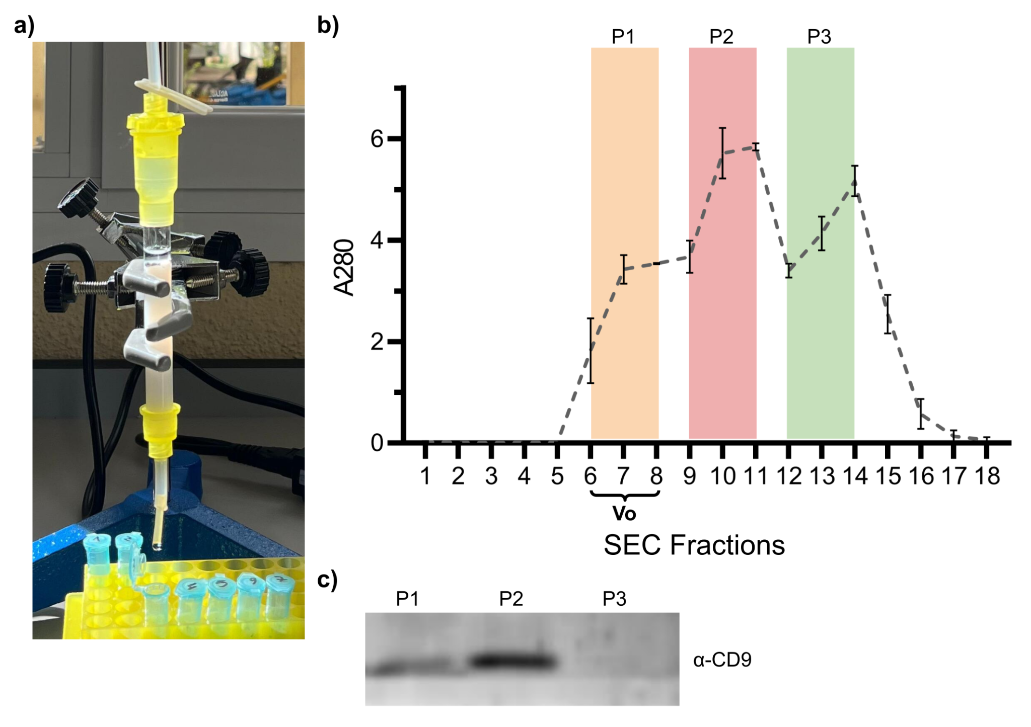

Supplementary Figure 1. SuperdexTM 200 size-exclusion chromatography (SEC) column performance and fraction characterization. (a) Representative image of the self-packed SuperdexTM 200 gravity-flow column used for EV isolation. (b) Elution profile obtained by measuring absorbance at 280 nm (A280) across 18 consecutive fractions (0.5 mL each) collected using PBS as the running buffer. The void volume (V₀) is indicated. Shaded regions denote pooled fractions (P1–P3) selected based on the protein elution pattern. (c) Western blot analysis of pooled fractions showing detection of the EV marker CD9. Fractions were concentrated by ultracentrifugation at 100,000 × g for 90 min at 4 °C prior to analysis. Representative data from independent replicates (n = 3) are shown.

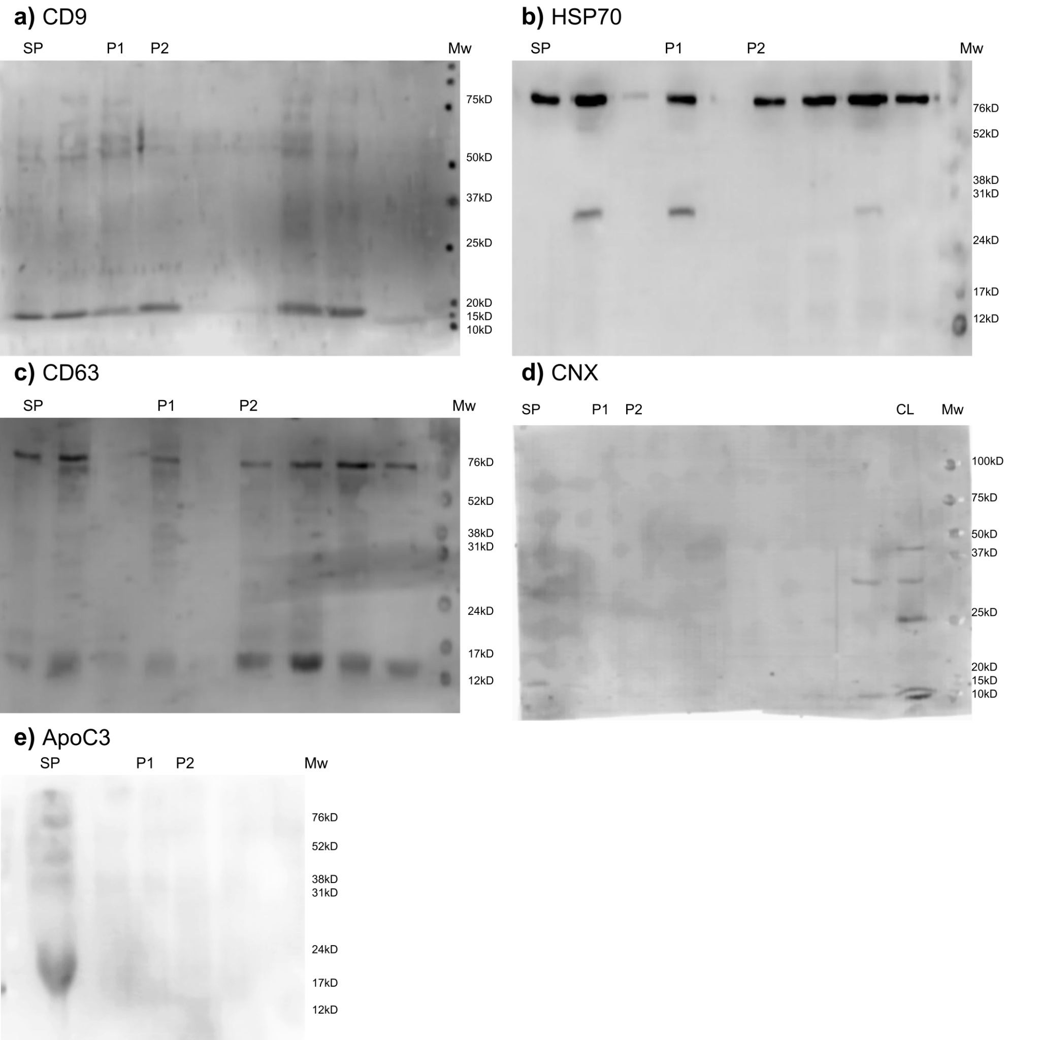
Supplementary Figure 2. Full Western blot images were obtained for the EVs-specific markers CD9 (a), CD63 (b), HSP70 (c), as well as for the EVs negative marker Calnexin (CNX) (d), and ApoC3 (e). Sequential probing on the same membrane was used to detect CD63 (rabbit) and HSP70 (mouse): HSP70 was revealed first, the membrane was washed, and then CD63 was revealed.

