Supplementary information for Separating Chromera velia Zoospores from Culture and Estimating Their Average Motility Speed and Lifespan

Jitka Richtová^{1, $}, Dorsaf Ennaceur^{1, 2} and Miroslav Oborník^{1, 2,} *

¹Institute of Parasitology, Biology Centre CAS, České Budějovice, Czechia
²Department of Molecular Biology, Faculty of Science, University of South Bohemia, České Budějovice, Czechia
$Present address: Institute of Plant Molecular Biology, Biology Centre CAS, České Budějovice, Czechia
*For correspondence: obornik@paru.cas.cz

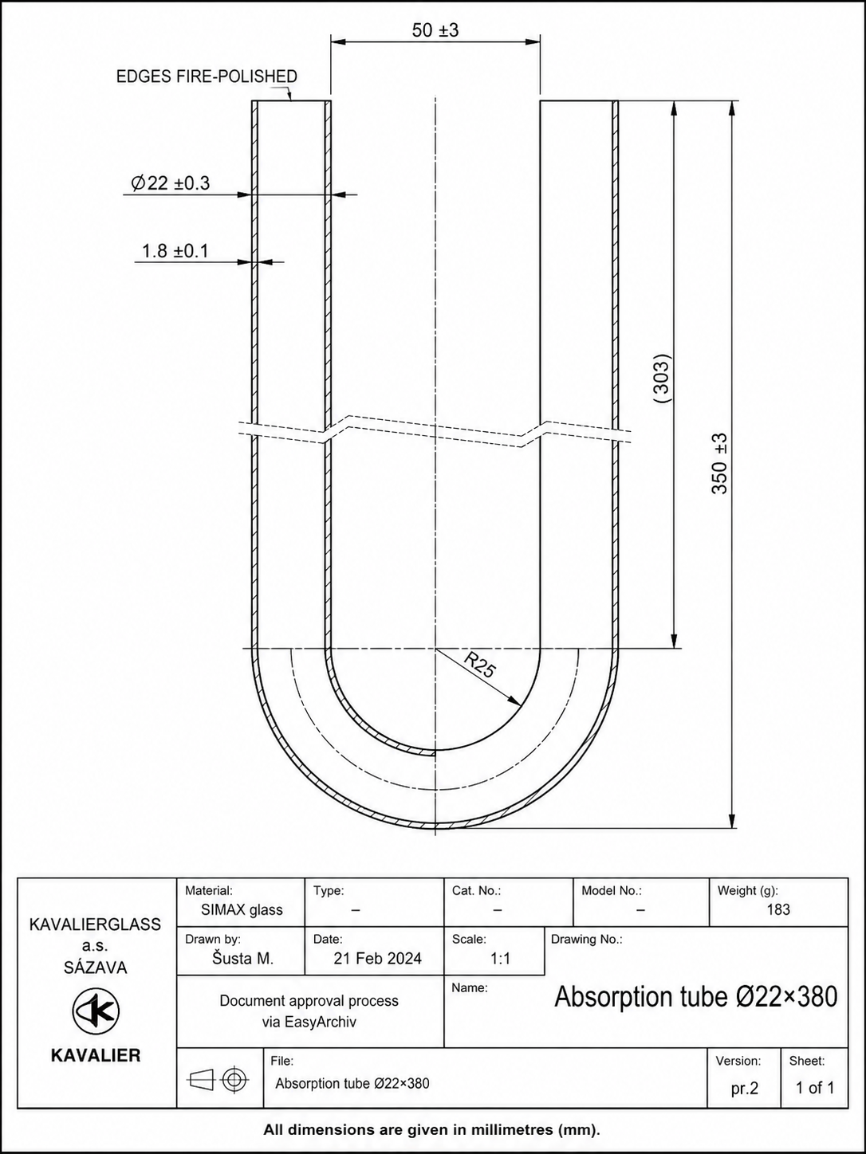

Figure S1. Technical drawing of the U-shaped glass tube used for zoospore isolation

