Supplementary information for Human iPSC Line SCTi003-A Differentiation into Kidney Organoids

Katarzyna Szymanska^{1,} *, Magdalena Karwatka¹, George Parpas¹, Erica L. Harris¹, Andrew L. Barlow² and Colin A. Johnson^{1,} *

¹Division of Molecular Medicine, Leeds Institute of Medical Research at St James’s, University of Leeds, Leeds, UK
²Media Cybernetics, 1700 Rockville Pike, Suite 240, Rockville, MD, USA
*For correspondence: C.Johnson@leeds.ac.uk; k.szymanska@leeds.ac.uk

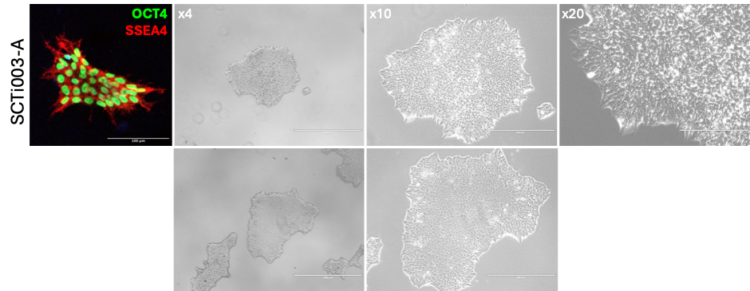

Figure S1. SCTi003-A KiO labelled with pluripotency markers and bright field images of cells colonies at different magnifications. IF labelled colony is different to the one shown in bright field images to the right. Red – SSEA4 (SSEA-4 [MC813-70] AlexaFluor 555 1:50, BD Bioscience, catalog number: 560218); green – OCT4 (goat anti – OCT-3/4 1:30, R&D Systems, catalog number: AF1759). Scale bar = 100 μm. Bright field images, top panel shows the same colony at 4×, 10× and 20× magnifications. Bottom panel shows another example of SCTi003-A colonies at x4 and x10 magnifications. Scale bar for bright field image 4× = 1000 μm, 10× = 400 μm, 20× = 200 μm.
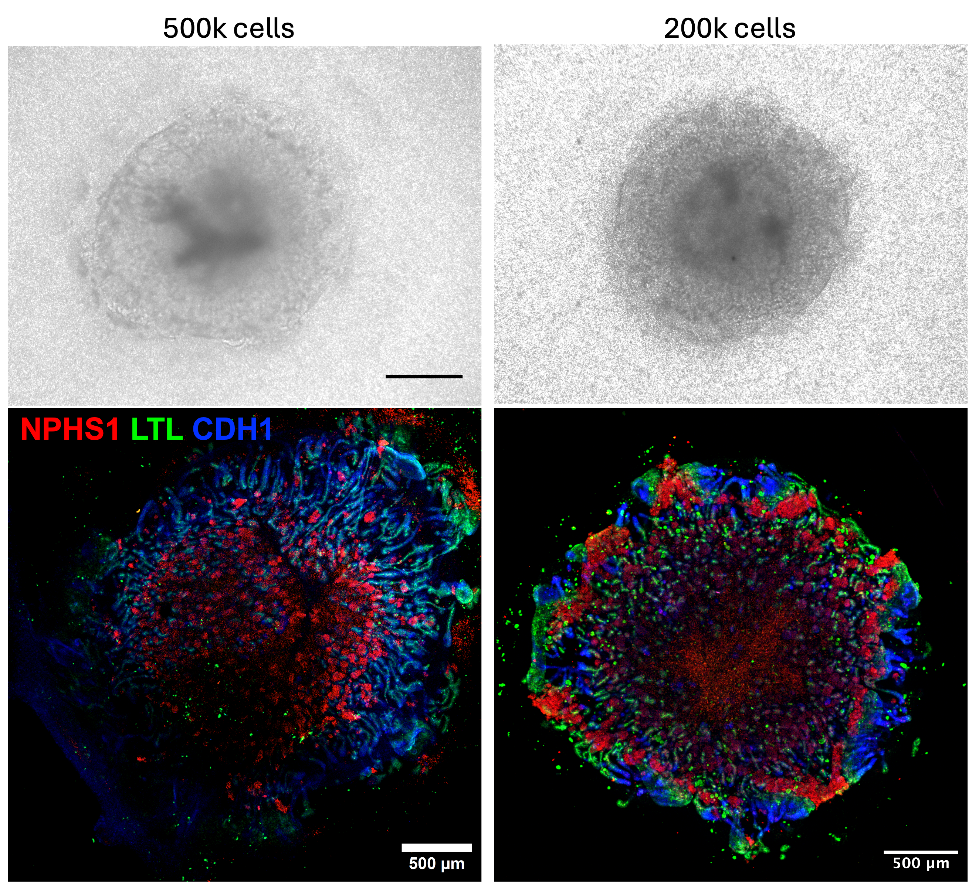

Figure S2. SCTi003-A KiO differentiated on ALI using different cell number. 500k or 200k cells were used to set up 3D differentiation. We find 200k cells to be the optimal cell number. Red – NPHS1, podocytes; green – LTL, proximal tubues; blue – CDH1 – distal tubules and collecting ducts. Scale bar = 500 μm.

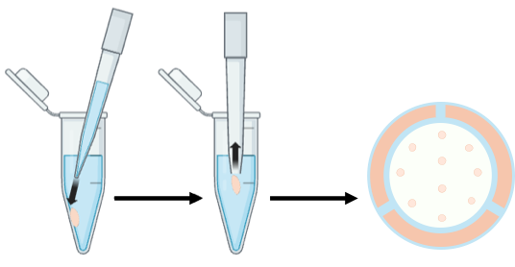

Figure S3. Schematic illustration demonstrating how to efficiently transfer a pellet of IM cells with minimal disruption to ALI culture. First aspirate some media, then forcefully dispense it on the side of the tube wall with normal 1 mL pipette tip to lift the pellet off the tube wall. Change to wide-bore 1 mL tip and aspirate floating pellet with minimal amount of carry-over media and transfer to ALI plates containing pulse media. Space pellets at equal distances on the membrane (image on the right). Created in https://BioRender.com.

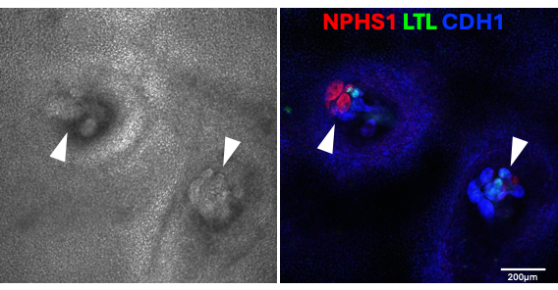

Figure S4. Bright field (left) and IF images (right) of stem cells differentiated into kidney structures in 2D culture. White arrowheads indicate tubules. Red – NPHS1, podocytes; green – LTL, proximal tubules; blue – CDH1 – distal tubules and collecting ducts. Scale bar = 200 μm.

