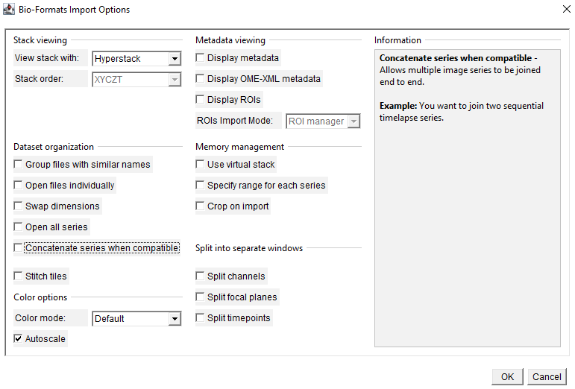
Figure S1. Import options in the Bio-Formats Import Options used in this protocol. A screenshot of the Bio-Formats Import Options pop-up window when Fiji loads a raw ZEN file. This is the default option used in this protocol.

Figure S2. Thresholding pipeline to make a mask of endo-lysosomal regions. (A) A 15 × 15 µm subregion of a whole-field image was specified and duplicated. (B) In this example, after splitting the channels, this window shows the far-red channel (designated Ch1) of Rab7-positive endo-lysosomes (iRFP-FRB-Rab7) within the subregion. (C) In this Threshold window, adjust the minimum threshold (top slider) until the endo-lysosomes are accurately marked, and click “Apply”.

Figure S3. Measuring the fluorescence intensity in the GAI- or FKBP-fused fluorescence channel within the mask of endo-lysosomal regions. (A) After the selection is created, the endo-lysosomal regions are outlined in yellow. (B) The selection is recorded in this ROI manager window. (C) In this example, this window shows the red channel (designated Ch2) of cytosolic RFP-FKBP before dimerization. Click on the registered selection in (B) and the endo-lysosomal regions will be outlined in yellow as shown. (D) After executing the “Measure” command, this pop-up window displays the measurements based on the configurable preset parameters using the “Set Measurements…” command. The “Mean” column is the mean fluorescence intensity of the red channel within the endo-lysosomal mask.

