Supplementary information for “A Simple and Adaptable Method for cloning genes into transposon vectors using Topo and Restriction Systems for chicken embryo transgenesis.”

Pamela Kirimi^{1,}*, Noah Okumu^{2,}, John M Maingi¹,Joseph Ngeranwa¹, Philip Nyaga³ and Yatinder Binepal⁴

¹Department of Biochemistry, Microbiology and Biotechnology, Kenyatta University, Nairobi, Kenya
²Health Program, International Livestock Research Institute, Nairobi, Kenya
³The University of Nairobi, Nairobi, Kenya.
⁴Kenya Agricultural Livestock Research Organization, Nairobi, Kenya
*For correspondence: pammykirimi98@gmail.com

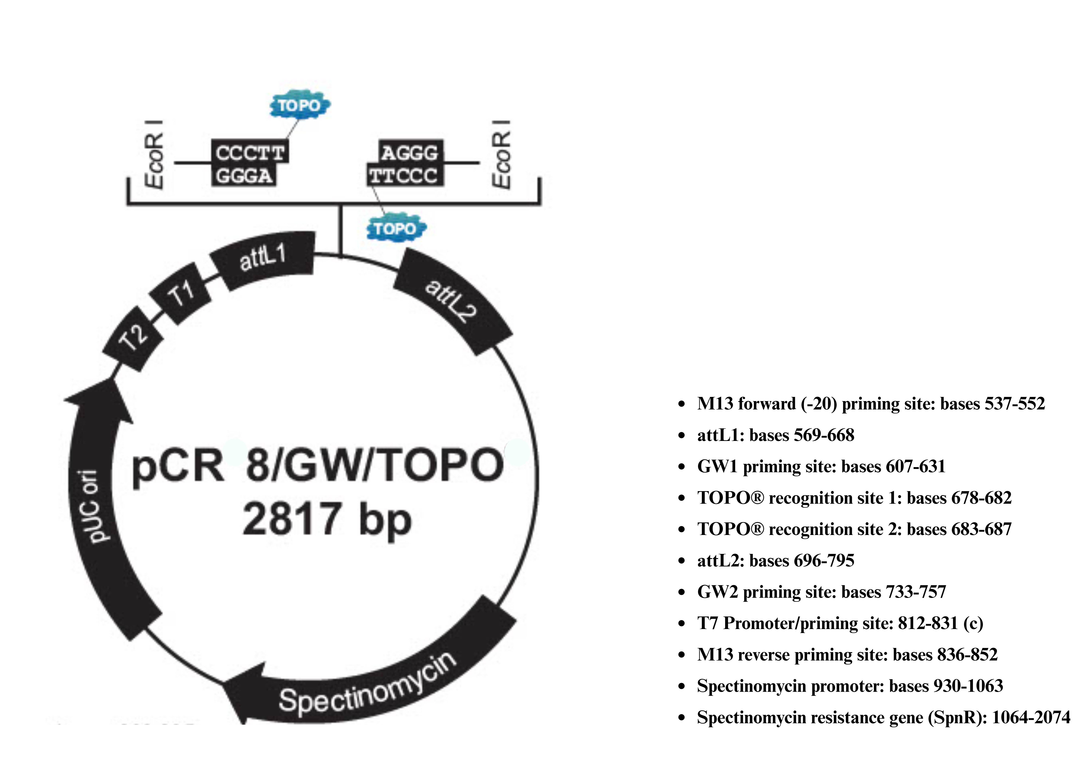

Figure S1. Annotated Map of the TOPO Cloning Vector Highlighting Key Features. Source: [20].

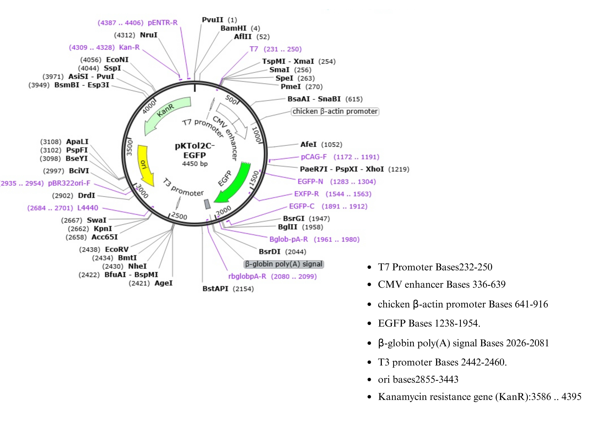

Figure S2. pKTol2C-EGFP Vector Map with Annotated Features. Source: [21].

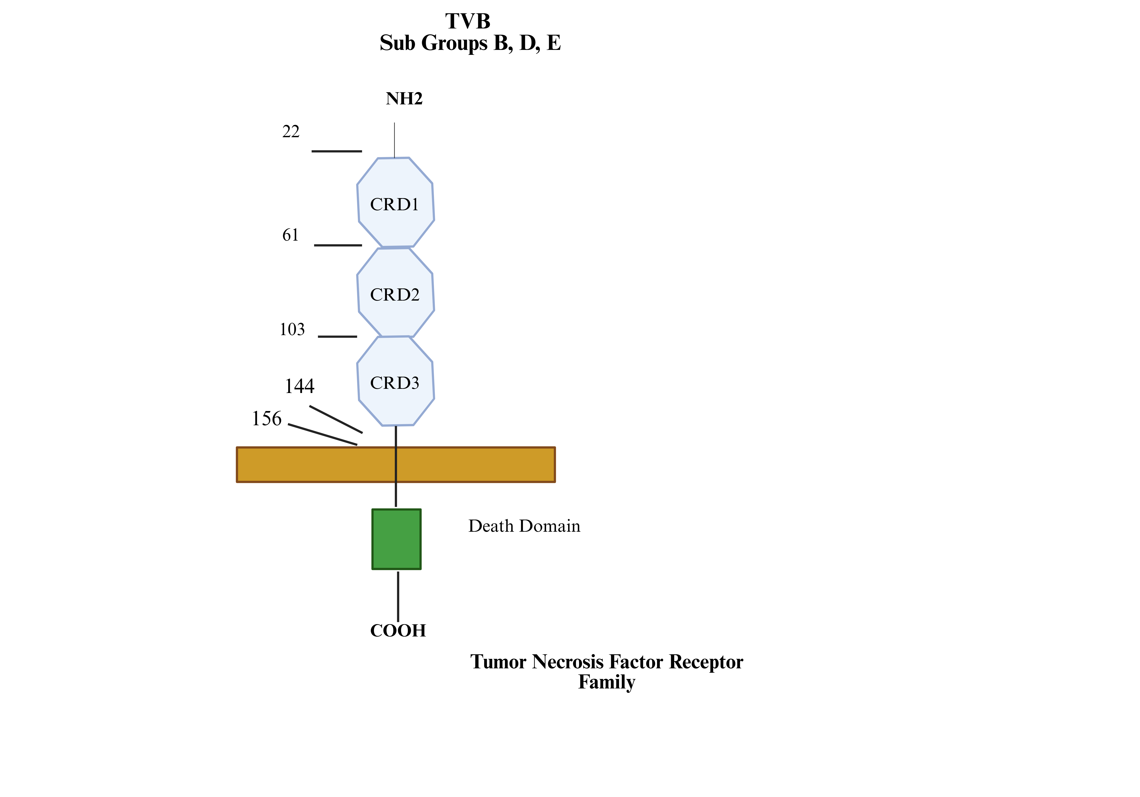
Figure S3. Schematic Representation and Key Residue Positions of Functional Domains in the Chicken TVB Receptor, a Tumor Necrosis Factor Receptor Family Member Mediating Avian Leukosis Virus Entry (Subgroups B, D, and E). Adapted from: [27, 28].

